Bahria University,

Karachi Campus



LAB ASSIGNMENT NO.

_______**4**_______

LIST OF TASKS

|  |  |
| --- | --- |
| TASK NO | OBJECTIVE |
| 1. | Implement Factory pattern for creating pages and popups(Modals, Alerts, etc.) in website for pages separate interface defined and for popups separate interface defined. |
| 2. | Implement factory pattern for creating Ranks/Positions of employees |
|  |  |
|  |  |
|  |  |
|  |  |
|  |  |
|  |  |
|  |  |
|  |  |

Submitted On:

___02-04-2020___

(Date: DD/MM/YY)

**Question1:** Implement Factory pattern for creating pages and popups(Modals, Alerts, etc.) in website for pages separate interface defined and for popups separate interface defined

**MAIN**

static void Main(string[] args)

{

FCWeb fcweb = new FCWeb();

PopUpsFactory PUF = new PopUpsFactory();

Console.WriteLine("What do you want to visit :\n1)Website\n2)Popups\nwrite 1 or 2");

String opt0 = Console.ReadLine();

while (true)

{

if (opt0 == "1")

{

while (true)

{

Console.WriteLine("Enter option: ");

String opt = Console.ReadLine();

Iwebsite IWB = fcweb.getWeb(opt);

if (opt == "0")

{

break;

}

IWB.Header();

IWB.nav();

IWB.Body();

IWB.Footer();

}

}

else if (opt0 == "2")

{

Console.WriteLine("Enter option: \n1)Modal \n2)Alerts\nwrite 1 or 2");

String opt1 = Console.ReadLine();

IpopUps IPU = PUF.factory(opt1);

IPU.message();

}

}

}

**INTER FACE IWEBSITE:**

interface Iwebsite

{

public string WebSiteName { get; }

public void Header();

public void nav();

public void Body();

public void Footer();

}

}

**Class Home:**

class Home : Iwebsite

{

public string WebSiteName

{

get { return "FCWeb"; }

}

public void Header()

{

Console.WriteLine("_______________Header_______________");

}

public void nav()

{

Console.WriteLine("__ HOME__ About Us __ Contact Us ____");

Console.WriteLine(" __________________________________________");

}

public void Body()

{

Console.WriteLine(" ___________________________________________");

for (int i = 0; i < 10; i++)

{

Console.WriteLine("| |");

if (i == 5)

{

Console.WriteLine(" Hello This is the body of HOME PAGE ");

Console.WriteLine("__________________________________________");

}

}

Console.WriteLine(" _____________________________________________");

}

public void Footer()

{

Console.WriteLine(" ____________________________________________");

Console.WriteLine(" _________________FOOTER_____________________");

}

}

}

**Class Contact Us:**

class Contact_Us:Iwebsite

{

public string WebSiteName

{

get { return "FCWeb"; }

}

public void Header()

{

Console.WriteLine("______________Header______________");

}

public void nav()

{

Console.WriteLine("__ Home__ About Us __ CONTACT US ____");

Console.WriteLine("__________________________________________");

}

public void Body()

{

Console.WriteLine("___________________________________________");

for (int i = 0; i < 10; i++)

{

Console.WriteLine("| |");

if (i == 5)

{

Console.WriteLine(" Hello This is the body of CONTACT US PAGE ");

Console.WriteLine("__________________________________________");

}

}

Console.WriteLine("_____________________________________________");

}

public void Footer()

{

Console.WriteLine("____________________________________________");

Console.WriteLine("_________________FOOTER_____________________");

}

}

}

**Class About Us:**

class About_Us:Iwebsite

{

public string WebSiteName

{

get { return "FCWeb"; }

}

public void Header()

{

Console.WriteLine("______________Header______________");

}

public void nav()

{

Console.WriteLine("__ Home__ ABOUT US __ Contact Us ____");

Console.WriteLine("__________________________________________");

}

public void Body()

{

Console.WriteLine("___________________________________________");

for (int i = 0; i < 10; i++)

{

Console.WriteLine("| |");

if (i == 5)

{

Console.WriteLine(" Hello This is the body of ABOUT US PAGE ");

Console.WriteLine("__________________________________________");

}

}

Console.WriteLine("_____________________________________________");

}

public void Footer()

{

Console.WriteLine("____________________________________________");

Console.WriteLine("_________________FOOTER_____________________");

}

}

}

**Factory(FCWeb) CLASS:**

class FCWeb

{

public Iwebsite getWeb(string selectPage) {

if (selectPage == "1")

{

return new Home();

}

else if (selectPage == "2")

{

return new About_Us();

}

else if (selectPage == "3")

{

return new Contact_Us();

}

else {

return null;

}

}

}

}

**Popup Interface:**

interface IpopUps

{

void message();

}

**ALERT CLASS:**

class Alert:IpopUps

{

public void message()

{

Console.WriteLine("Hello I am an Alert");

}

}

}

**MODAL CLASS:**

class Modals:IpopUps

{

public void message() {

Console.WriteLine("Hello I am a modal");

}

}

**Factory Class:**

class PopUpsFactory

{

public IpopUps factory(string option) {

if (option == "1")

{

return new Alert();

}

else if (option == "2")

{

return new Modals();

}

else {

return null;

}

}

}

}

**OUTPUT:**

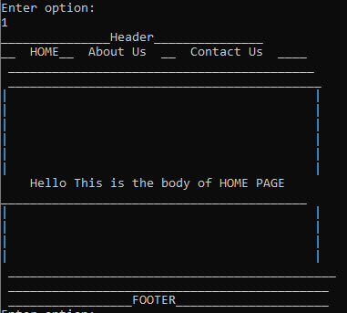

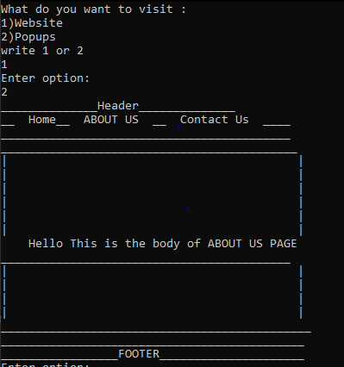

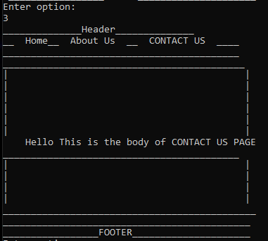

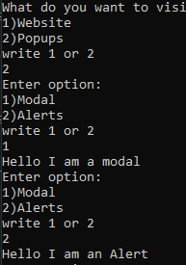

**Question No. 2** Implement factory pattern for creating Ranks/Positions of employees

**MAIN:**

Console.WriteLine("Enter the Employe Category 1)Manager 2)Peon:");

String opt4 = Console.ReadLine();

emp_Information e_I = new emp_Information();

Rank_Position R_P = e_I.getInfo(opt4);

R_P.salary();

Console.WriteLine("Employee ID: {0}",R_P.emp_id);

Console.WriteLine("Emplpyee Name: {0}",R_P.emp_name);

Console.WriteLine("Employee Identity No. {0}",R_P.emp_CNIC);

Console.WriteLine("Employee Age: {0}",R_P.emp_age);

Console.WriteLine("Employee Salary: {0}",R_P.salary());

**INTERFACE:**

interface Rank_Position

{

String emp_name { get; }

int emp_id { get; }

String emp_CNIC { get; }

int emp_age { get; }

double salary();

}

**MANAGER CLASS:**

class Manager:Rank_Position

{

public String emp_name {

get { return "SYED ALI ABBAS"; }

}

public int emp_id

{

get { return 1; }

}

public String emp_CNIC

{

get { return "0000-1111-2222"; }

}

public int emp_age {

get { return 40; }

}

public double salary() {

return 45000.9;

}

}

**PEON CLASS:**

class Peon:Rank_Position

{

public String emp_name

{

get { return "SABBA ILA DEYS"; }

}

public int emp_id

{

get { return 2; }

}

public int emp_age

{

get { return 25; }

}

public String emp_CNIC

{

get { return "2222-3311-2002"; }

}

public double salary()

{

return 19000;

}

}

**FACTORY CLASS:**

class emp_Information

{

public Rank_Position getInfo(String getinfo) {

if (getinfo == "1")

{

return new Manager();

}

else if (getinfo == "2")

{

return new Peon();

}

else {

return null;

}

}

}

**OUTPUT:**

